Linked List Candyland – Teaching the Hardest Topic in Computer Science

Project Description. This project is a standalone module for CSCI 41 (Data Structures) that can also be used in a number of classes that teach Pointers or Linked Lists (the hardest topic in computer science), including ENG 40, CSCI 40, and junior-level Data Structures as well at 4-year universities. It will focus on the C++ language, which is absent from OER Data Structures texts, and include:
- A newly-written chapter (for a possible future OER textbook) on the topic of linked lists and pointers, written in such a way that students will be able to actually understand it. A pointer is a way of referring to a variable by where it is in RAM (such as memory address 0x40122000), rather than by name (such as ‘x’), similar to how you can refer to “the residents of 1234 Main Street” rather than “Mr. Smith”. Using this extra level of indirection hurts the brain, so students will need a well written chapter explaining it, combined with:
- A multi-stage programming assignment which takes students from never having seen a pointer before to writing code with them (actually working with and using a topic is the best way to learn a topic) to creating a data structure called a “linked list” in which data is held in lists of elements, with each element pointing to the element in the list after it (or NULL if it is the end of the line). This is a traditional homework assignment, and usually bores students to death, if they don’t understand it at all.
- However, this will be followed by students making a board game similar to Candyland! Each space on the board either points to the space after it, or is the end of the line, or in some cases is a branch in which case the player has a choice of which branch to take when they move on it.
- The graphical user interface will be provided to the students by the instructors, so all they need to do is write the code to do the linked lists and then they will see the spaces appear on the board!
- They then will write code to advance a player down the board using Candyland rules. I.e. if they draw a red card, then their piece advances to the next red square. If they draw a yellow card, it advances to the next yellow square, etc. For students to do this they must learn how to iterate down a linked list, which is one of the core fundamental skills of lists, and they will also be following pointer after pointer when doing this. They’ll work with pointers so much they’ll know them by heart when they’re finished.
- Since paths can branch and merge, this will actually foreshadow later topics in computer science (trees and graphs) where trees have two children, not just one, and graphs which have an all-to-all relationship of connections (like a social network on Facebook where anyone can friend anyone, and you can follow friend links to see how far you are away from Kevin Bacon or whatever).
This project will deliver a chapter of a textbook, full instructions for professors and students, the code skeleton for the homework assignment including the graphical user interface that students can slot their linked list/pointer code into, and debugging assistance so that if they don’t connect things up right (like a linked list with nobody pointing at it, not even the starting pointer, meaning that square can’t be moved to) the GUI will highlight it as an error so they can think about it, and visually see what their code is doing right and wrong. Here are terrible AI visualizations:
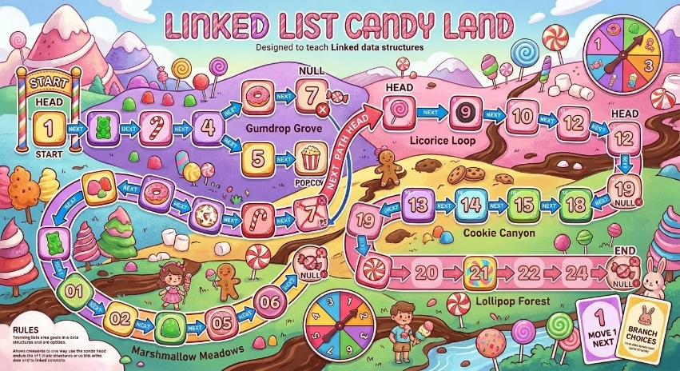

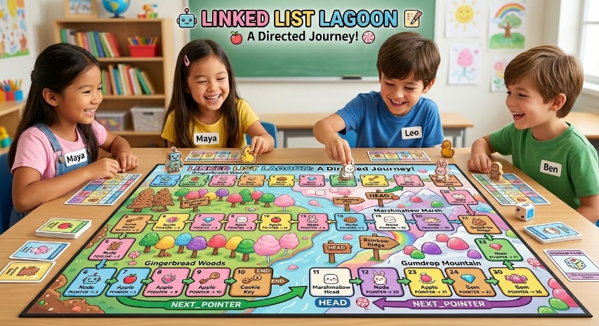

All of this will be Creative Commons licensed (BY-SA) and uploaded to OER Commons or a similar site to provide a good module on linked lists focusing on C++, something that is missing from other OER data structures textbooks. Some include C++ as a side note, but all of them focus on Java or Python. C++ is the third most popular programming language in the world, so there is a real need for this.
Project Timeline. List dates for completion of specific aspects. Include significant steps that will be taken and expected beginning and ending dates for the activities. This section should contain a detailed list regarding actions related to the completion of the project.
Ben Bohan and Bill Kerney will take OER and accessibility training by May 2026. The textbook will be finished by July 2026. Development on the GUI will take place through September 2026. It will be piloted in Fall 2026 and Spring 2027 in all classes that teach pointers and linked lists (ENG 40 with Bohan and CSCI 41 with Kerney), with the curriculum and tools revised after each pilot test run. The materials will be reviewed by Lawton Nichols after each revision, and potentially piloted in his CSCI 41 classes as well (both online and in-person). Final revisions will be done by April 2027 with the module (textbook chapter, instructions, homework assignment, GUI, starter skeleton code) uploaded to OER Commons or equivalent by May 2027. If successful, it will be submitted to SigCSE as a “Nifty Assignment” which means, if accepted, it will be used by professors around the world to teach pointers and linked lists.
Diversity. Sample images of students using the tool will be diverse. Topics and names will also come from diverse sources. Equity issues involving computer access will be taken into account. Not all people can afford computers with expensive graphics accelerators, especially with AI pushing component prices through the roof, so the GUI for this will be able to run on a potato if it has to, and we will look to see if it is feasible to make a web client so that any computer or smart phone with web access will be able to visualize it.
Peer Reviewers. Lawton Nichols has agreed to peer review this.

